for more information, please contact ESFRA @ 902-827-1461

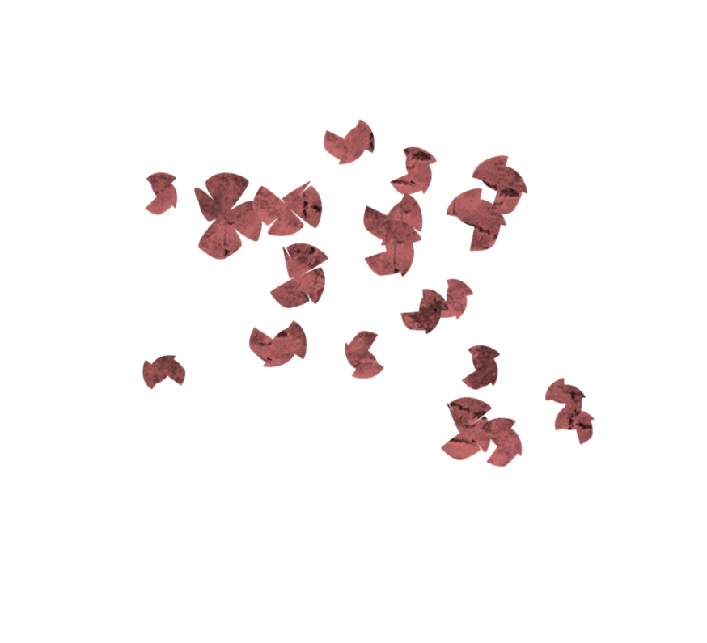

**Great Expectations**

Pre-Natal Program

**Fall 2018**

September 13th to November 1st

6:00 – 8:00 P.M.

Eastern shore family resource centre

5228 Highway #7, Suite 203 porters lake

